# EMR

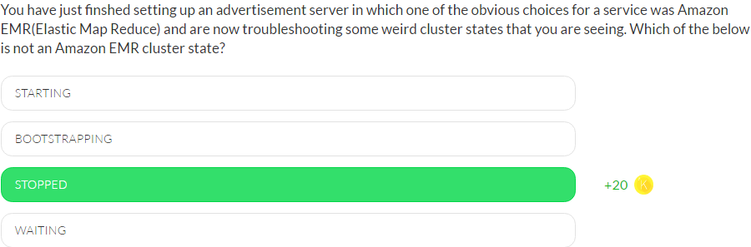

The different cluster states of an Amazon EMR cluster are listed below.

**STARTING** – The cluster provisions, starts, and configures EC2 instances.  
**BOOTSTRAPPING** – Bootstrap actions are being executed on the cluster.  
**RUNNING** – A step for the cluster is currently being run.  
**WAITING** – The cluster is currently active, but has no steps to run.  
**TERMINATING** - The cluster is in the process of shutting down.  
**TERMINATED** - The cluster was shut down without error.  
**TERMINATED_WITH_ERRORS** - The cluster was shut down with errors.

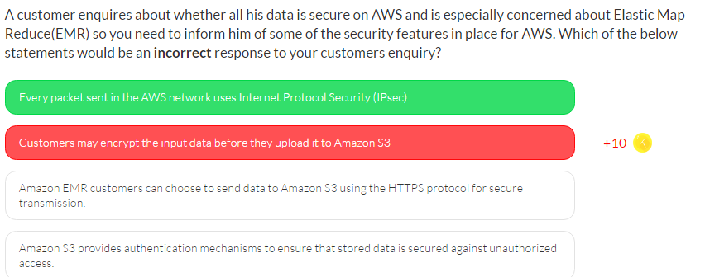

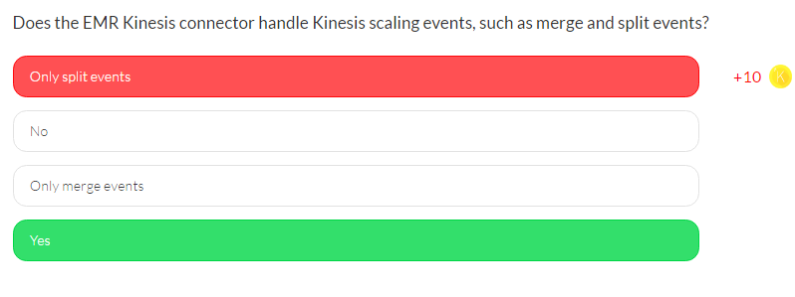

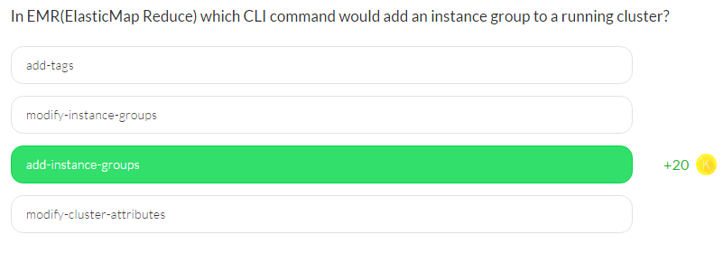

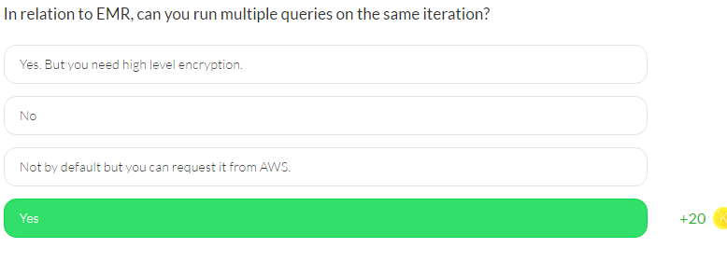

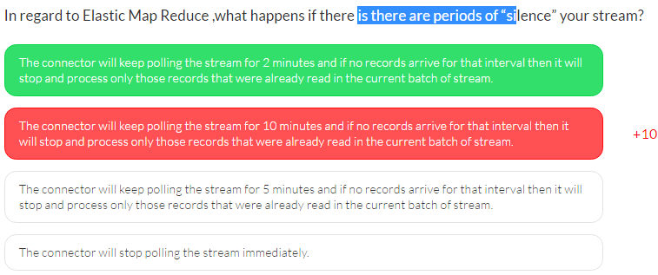

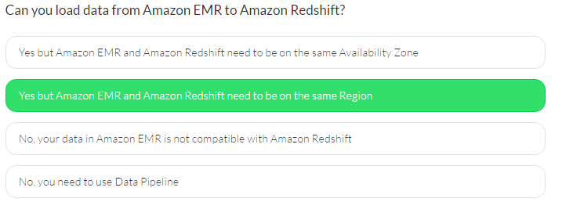

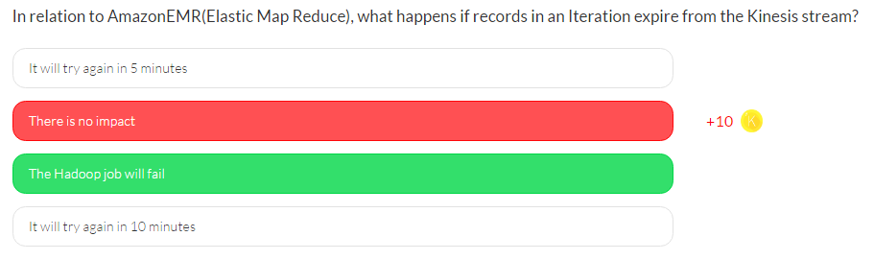

# Kinesis